# **The longest (or shortest) day of the year**

**Zoe's avatar**

[Zoe](https://substack.com/@zoeffc)

Jun 21, 2024

Share

Hi there!

The last couple of posts have been pretty heady. I gave you an introduction to Femme Futures Cooperative and waxed poetic about risk (if you want to check those out, all of the newsletters are archived on the BeeHiiv landing site [*here*](https://femme-futures.beehiiv.com/).) But I want this to be a place for the distribution of resources as much as for the distribution of ideas.

This week, I am going to do a bit of waxing poetic about inflection points, as we are at the solstice, but then I am going to share some practical tools. Just a warning, I get woo-woo, so buckle up. Don’t blame me, blame the stars, or at least the big one that we orbit around.

First some housekeeping:

📫 If a friend forwarded you this newsletter (then you have some really cool friends), and you may want to consider joining us [*here*](https://femme-futures.beehiiv.com/subscribe) for regular updates.

🧲 Got some thoughts you want to share? Join us on [*Discord*](https://discord.gg/592wuyvx?utm_source=femme-futures.beehiiv.com&utm_medium=referral&utm_campaign=the-longest-or-shortest-day-of-the-year) to chat all things newsletter and corporate life.

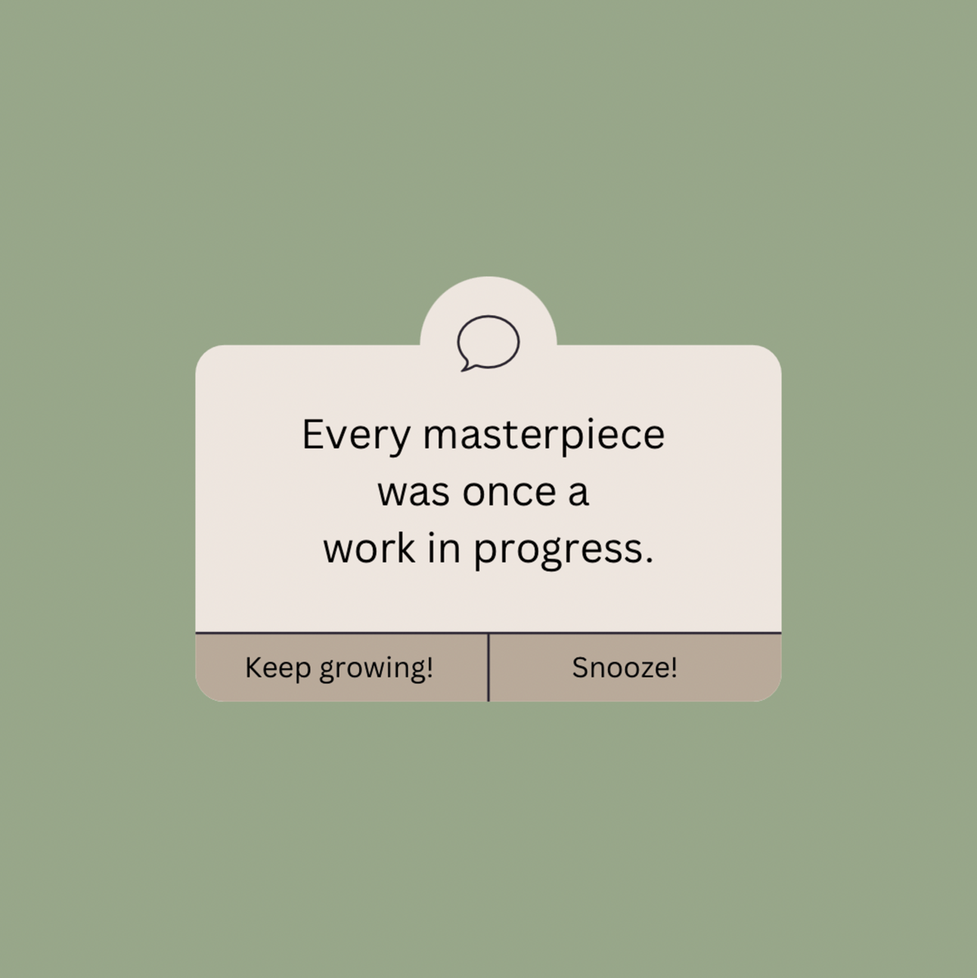

*art by me*

Yesterday was the solstice — the cosmic inflection point of the year. For me, it has come with a realization that my life is taking some pretty big turns.

The last couple of years have been challenging for me. I, like so many others, was in college when COVID-19 broke out, upending many of my plans for how my life was going to go. After college, I got lucky and landed what I thought was my dream job only to have it go sour on me a year in. So yea, I have dealt with my share of toxic workplaces. I have navigated the post-college ebb and flow of friendships and relationships, and now here I am; armed with a few more tools but still in way over my head.

The first half of 2024 was not how I expected it to be, and I am willing to bet that the second half of 2024 also won’t go to plan. As a perfectionist and a control freak, just writing that makes me want to die a little bit. I like my milestones and checklists. I like consistency and stability. But that’s not been the journey for me so far.

With the solstice, I am reminded to reflect on what has happened, and what might happen. On New Year’s Eve, my sister and I made vision boards, which I still have hung in my room. It is interesting to look at it now and see what still resonates with me, and what is a little off track. On it, there is a little mantra that says “What is meant for me will not pass me by” which is something that I have found myself repeating constantly this year. Woo-woo, I know, but it’s been reassuring as I navigate change, and sometimes we rely on whatever tools we have in order to figure out how to do this thing called life.

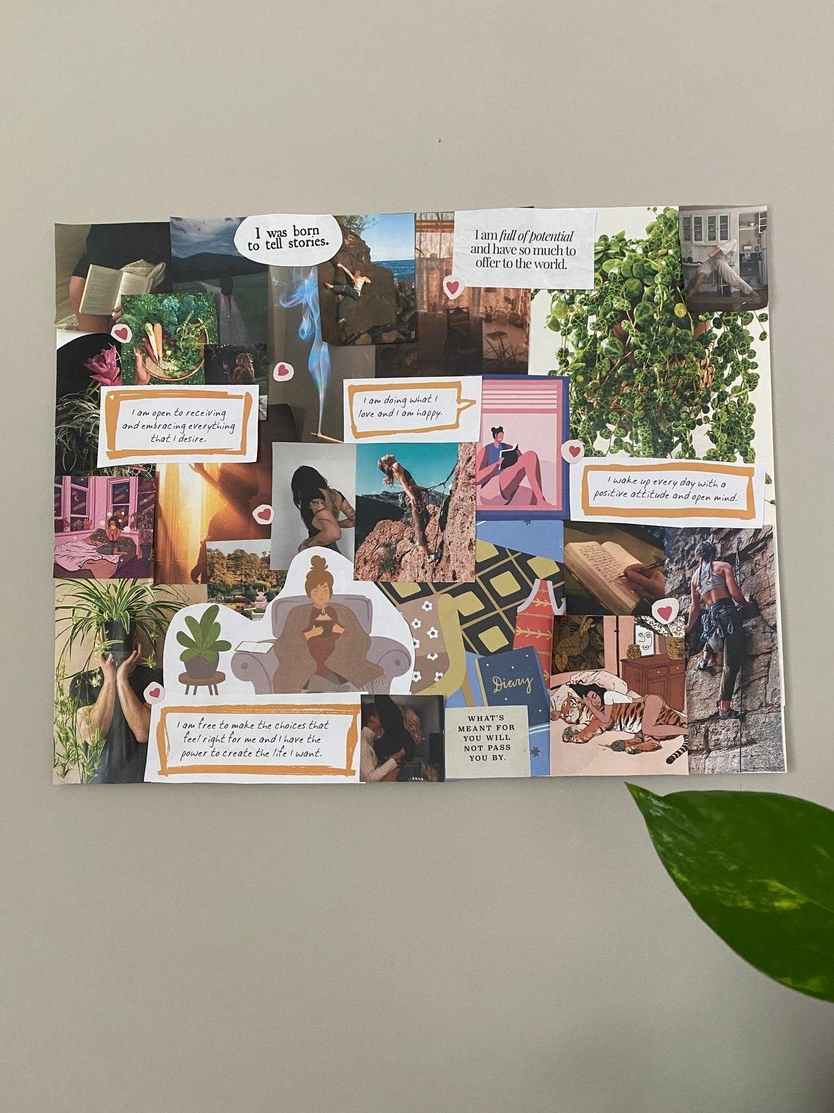

*My vision board for 2024*

Speaking of tools, I want to share a couple with you to encourage reflection and planning as we celebrate the solstice.

📌 **Resources**

✏️ Journal Prompt: Journal in response to the following questions:

1. What were the brightest highlights from the first half of 2024?
2. What am I proud of from the first half of 2024?
3. What are three things I want to work towards in the second half of 2024?

🐝 Update your work tracker: A friend of mine shared a helpful tool for keeping track of all of the projects that you do for work throughout the year. It is a simple spreadsheet that records *what the project is*, *what your role was on the project,* and *the timeframe or date of completion*. Unfortunately, there is no easy way to keep this up to date, but consider this some encouragement to update that. I know that’s something on my to-do list.

🎧 Guided Meditation [*by TheMindfulMovement*](https://www.youtube.com/watch?v=LUyaI0GLRio&ab_channel=TheMindfulMovement&utm_source=femme-futures.beehiiv.com&utm_medium=referral&utm_campaign=the-longest-or-shortest-day-of-the-year)

I hope that this gets you started!

Onwards,

Zoe

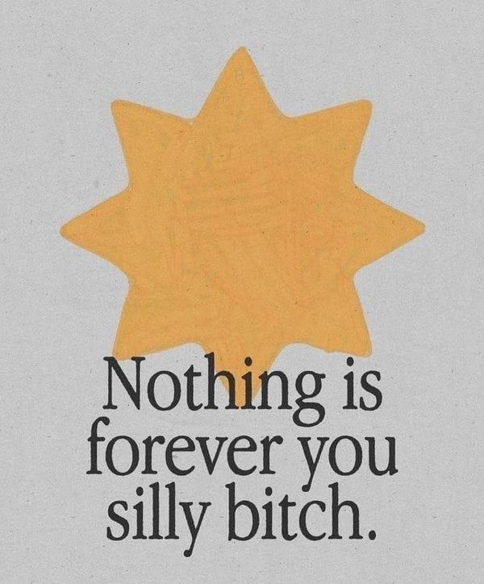

*Artist unknown*

**Femme Futures Cooperative Founding Principles**

💚 **Mission**: The mission of Femme Futures is to create a community space for young professionals who identify as over-achievers and activists to generate collective success by providing resources and platforms to thrive in challenging workplace environments.

💙 **Vision**: To contribute to a world where driven individuals are equipped with the tools, guidance, and connections to overcome systemic barriers, fully utilize their talents, and enact positive change in their organizations and communities.